SQL Server 2025 Express Edition Install Guide

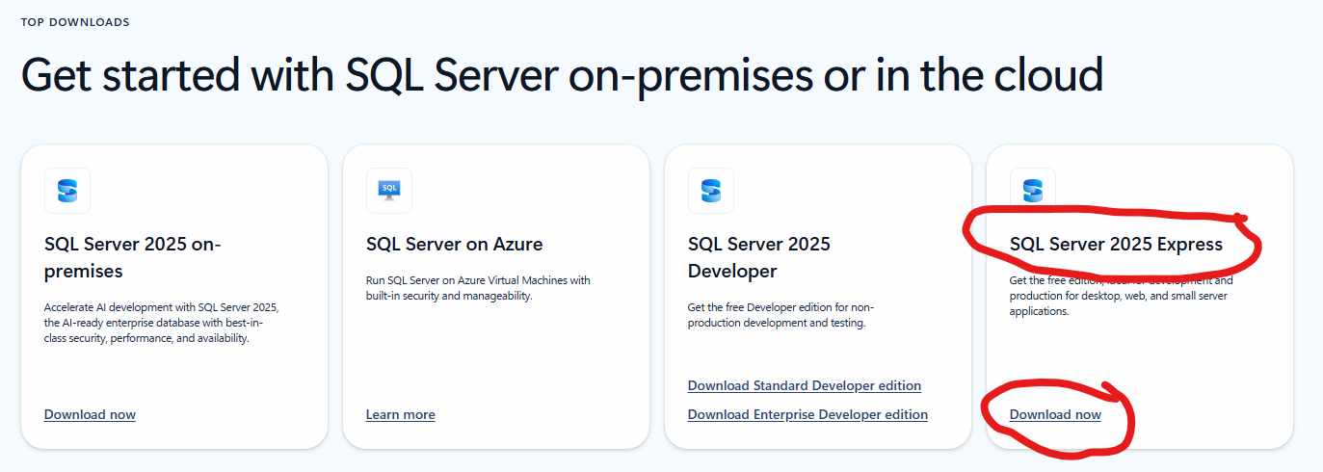

Click Download now on SQL Server 2025 Express
Check your Downloads folder and double-click on SQL2025-SSEI-Expr.exe if the installation does not start automatically.
Click Yes to “Do you want to allow this app to make changes to your device?”.

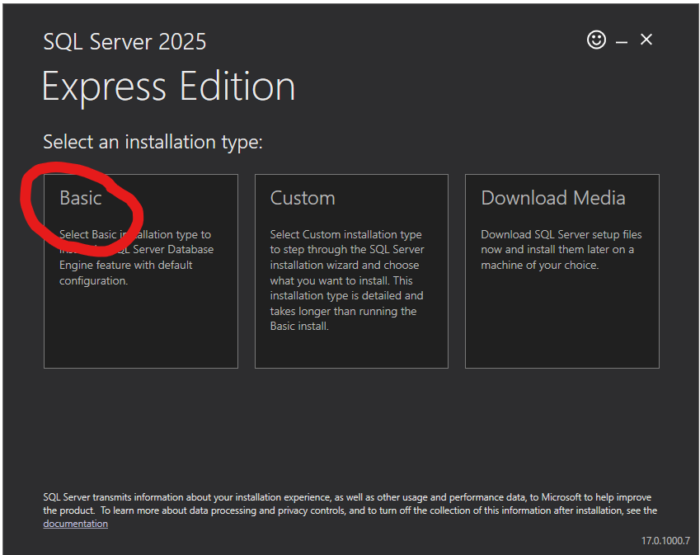

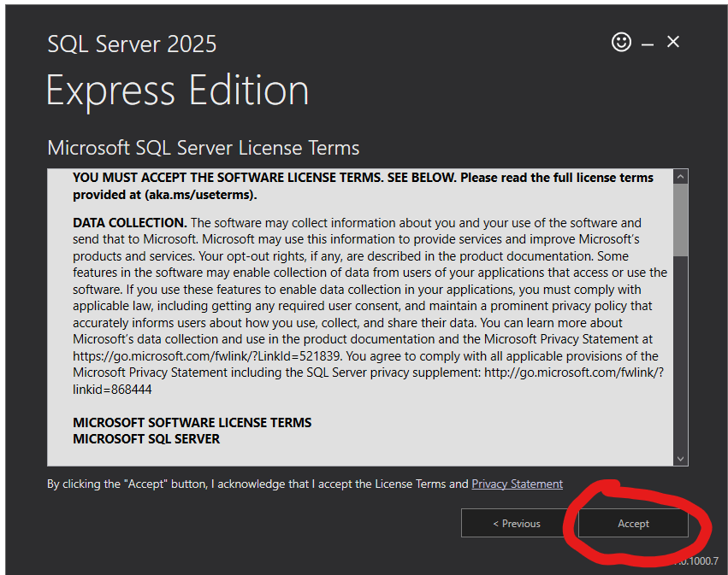

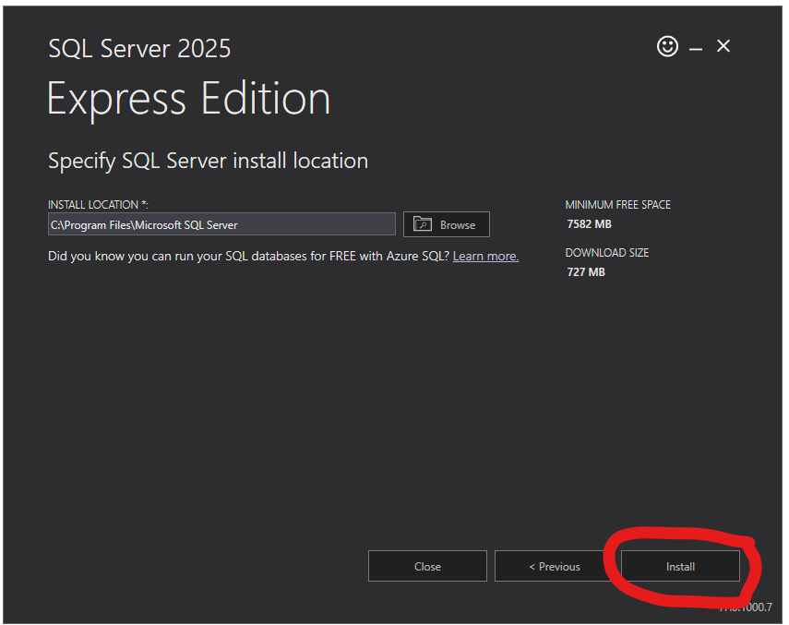

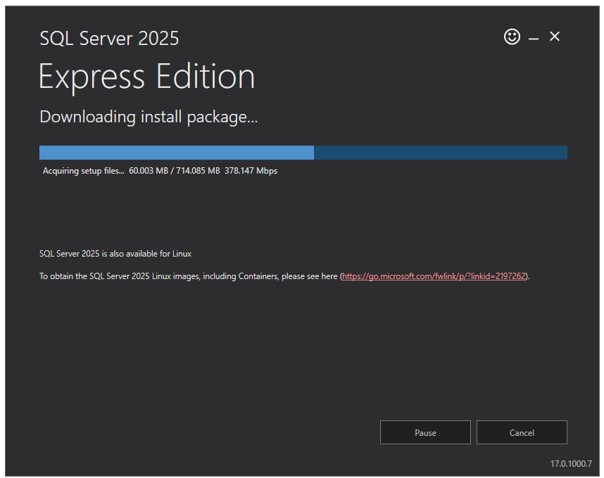
Download in progress

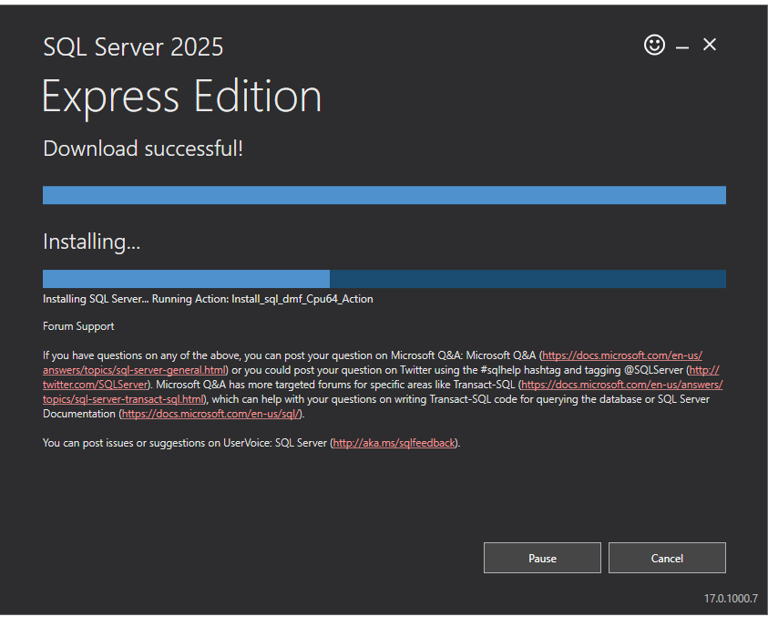
Installation in progress

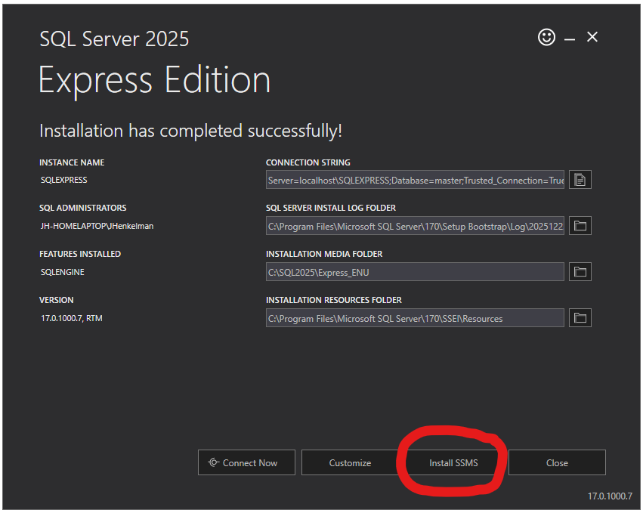

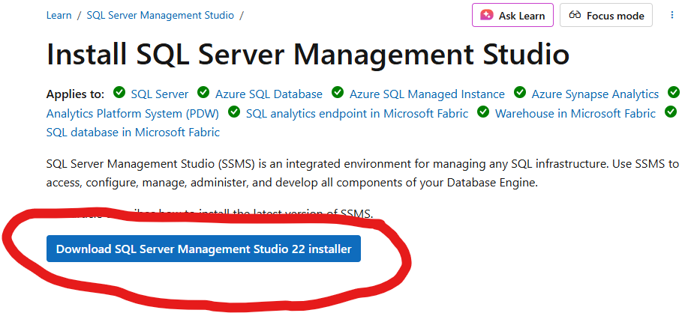
Check your Downloads folder if it does not start automatically
Double-Click on vs_SSMS.exe (it may take a few minutes to download)

Click Yes to “Do you want to allow this app to make changes to your device?”.

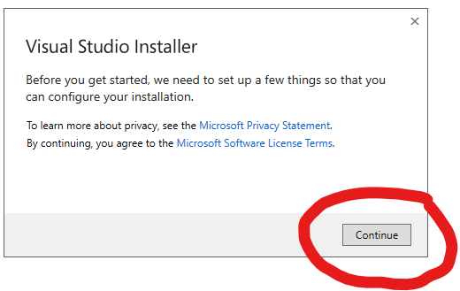
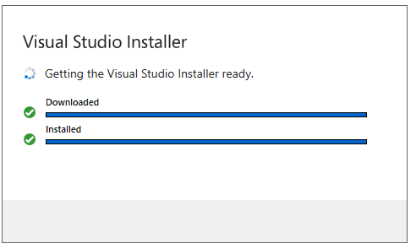

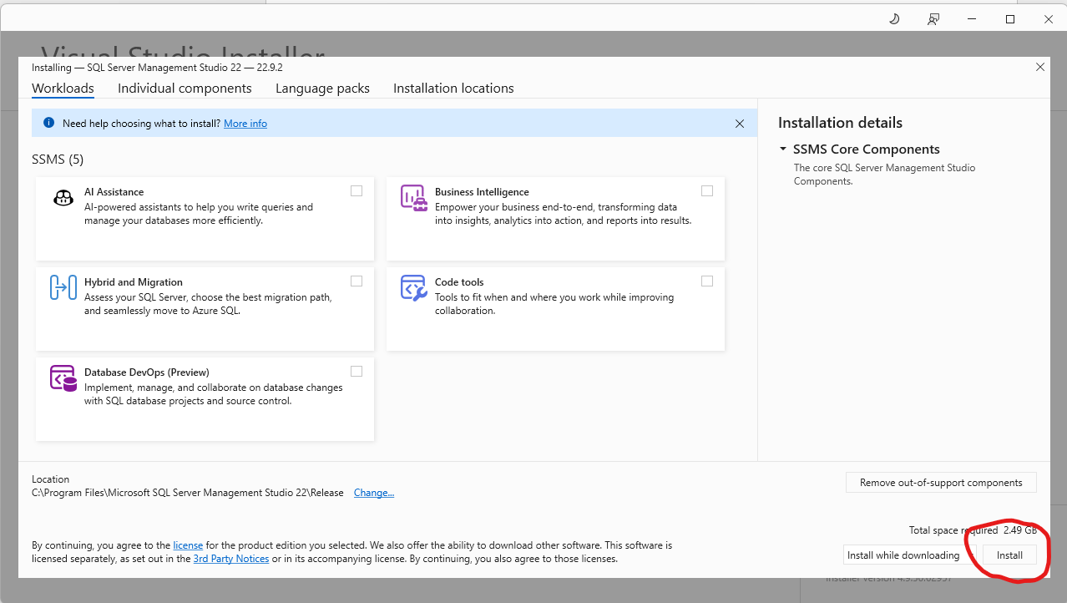

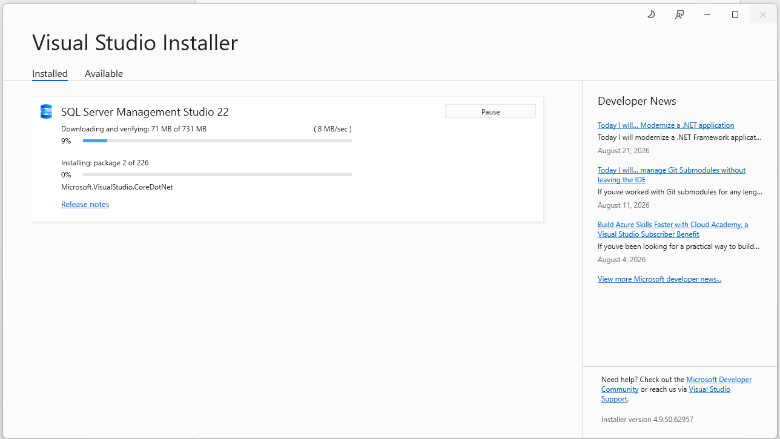

Installing…this may take a while.
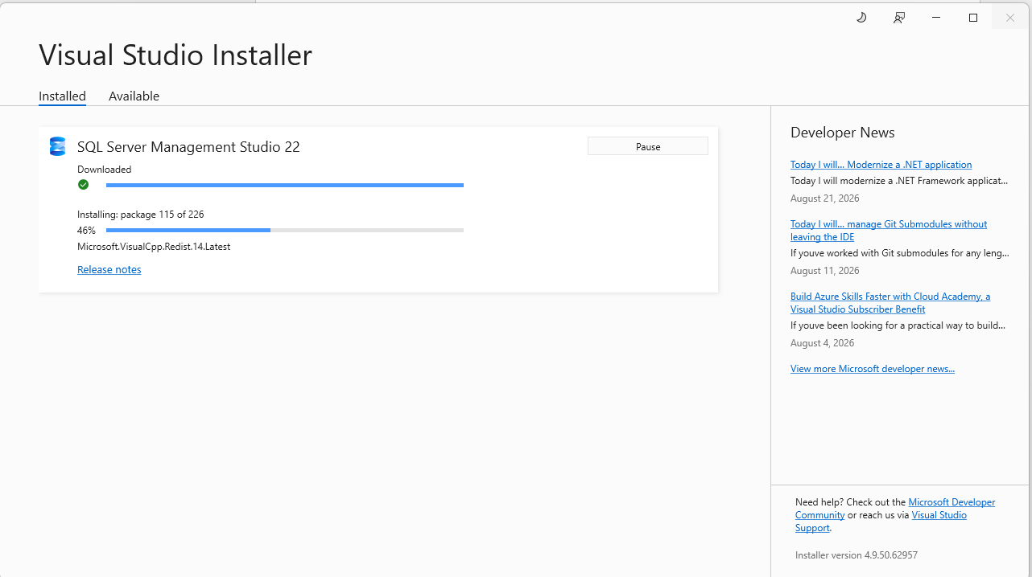

Be patient.
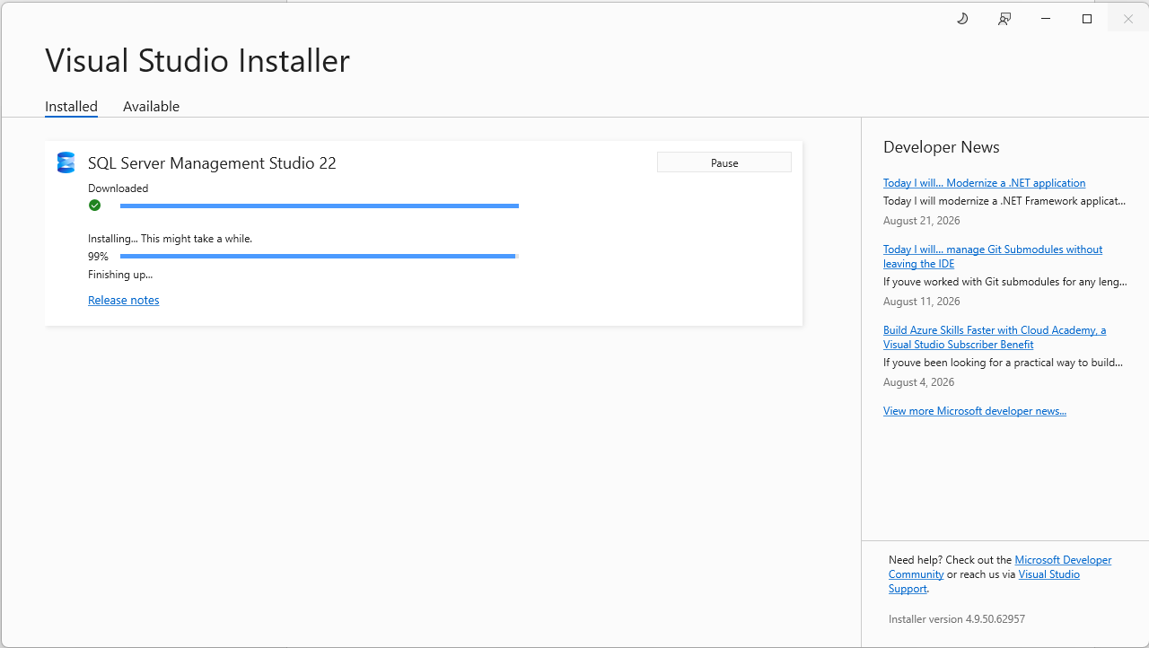

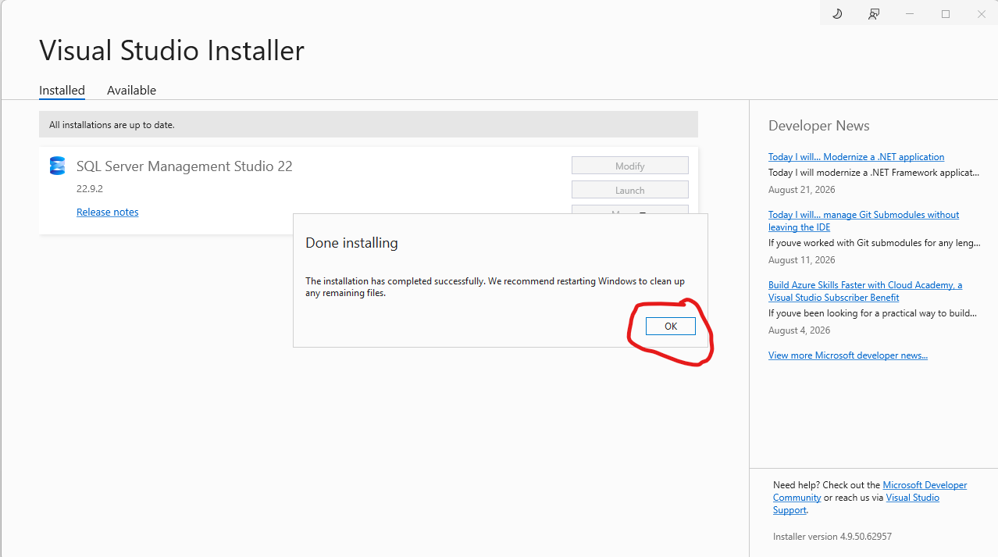

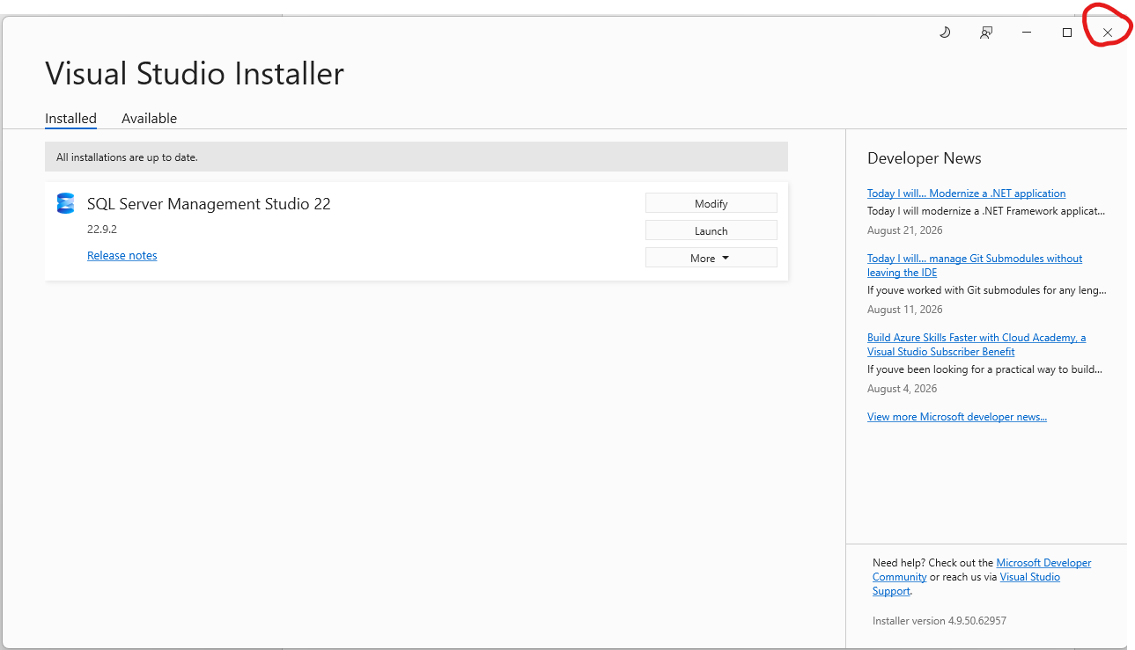
Close the Visual Studio Installer

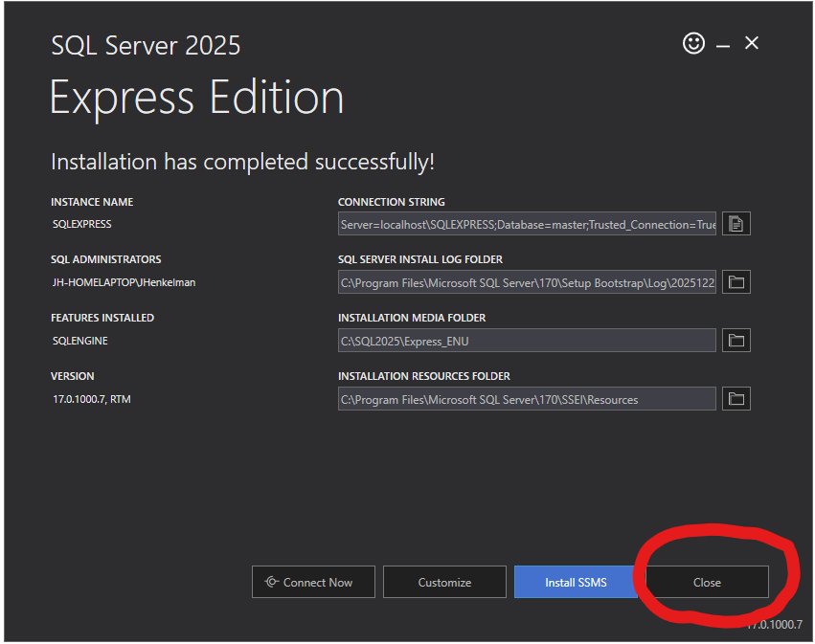

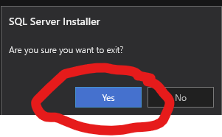
Close the SQL Server Express Edition installation, if it is still open.

You may now run SQL Server Management Studio

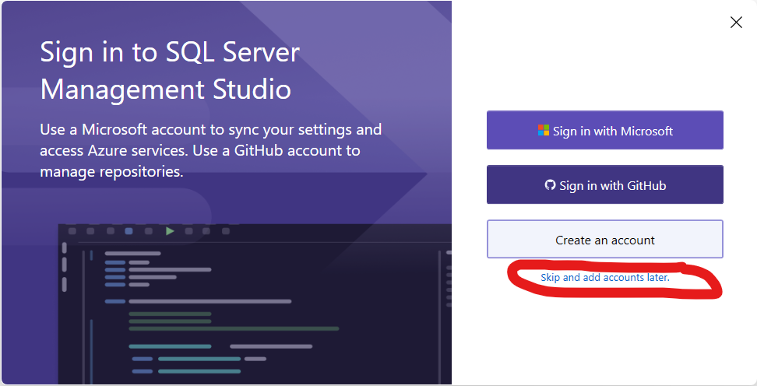

If you have a previous version of SQL Server installed, you may Import your settings. If you do not have a previous verion, or if you do not want to import those settings, click “Do no import”. You may not see this message at all.
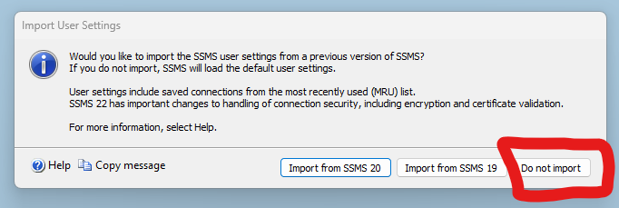

In the “Server Name” field, enter a period then a backslash then SQLEXPRESS, click the “Trust Server Certificate” check box, then click Connect.
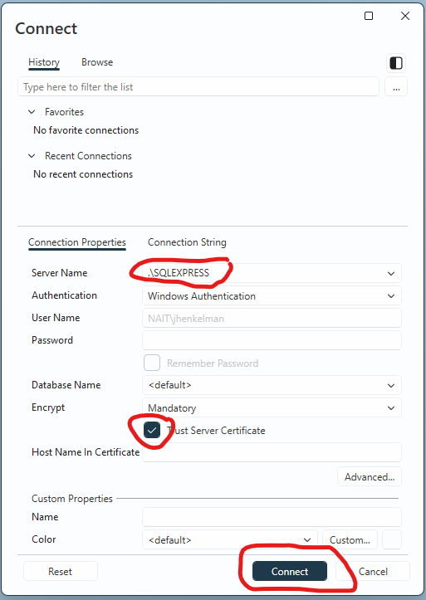

If that does not work, enter your machine name then a backslash then SQLEXPRESS, click the “Trust Server Certificate” check box, then click Connect.
You should now be connected to SQL Server.
To create a database, right click on Databases, Click on “New Database…”
